FlipKart Sale Performance
Name: Sanjana Gupta
Student ID: AF05213618
Batch Code: ANP-D4853
Project Name: FlipKart Sale Performance
Project Guide: Mrs. Rajshri Thete

Table of Contents
- Executive Summary
- Business Problem
- Project Objectives
- Dataset Overview
- Data Preparation
- Data Modeling
- DAX Measures
- Dashboard Design
- KPI Analysis
10. Visualizations
11. Business Insights
12. Business Recommendations
13. Conclusion
14. Future Scope
1. Executive Summary
The Flipkart Sales Performance Dashboard was developed using Microsoft Power BI to analyze sales data obtained from a publicly available dataset on Kaggle. The project transforms raw transactional data into meaningful business insights through interactive dashboards and visualizations. By utilizing Power Query, Data Modeling, and DAX measures, the dashboard enables users to monitor sales performance, profitability, customer behavior, regional trends, and product performance. The project demonstrates how Business Intelligence tools can support data-driven decision-making using real-world sales data.
2. Business Problem
E-commerce companies generate a large volume of sales transactions every day across different product categories, customers, locations, and payment methods. Analyzing this data manually is time-consuming and often fails to provide actionable insights.
To address this challenge, a publicly available Flipkart Sales Dataset from Kaggle was analyzed using Microsoft Power BI. The project focuses on transforming raw sales records into interactive dashboards that help identify sales trends, profitable products, customer purchasing patterns, and regional performance.
The company needs an interactive dashboard that answers important business questions such as:
Which category generates the highest sales?
- Which products generate maximum profit?
- Which states contribute the highest revenue?
- How do monthly sales change over time?
- Which payment method is most preferred?
- Which products receive the highest customer ratings?
- How do discounts affect profit?

3. Objectives
The objectives of this project are to:
- Analyze overall sales and profit performance.
- Monitor monthly and yearly sales trends.
- Identify top-performing products and categories.
- Evaluate state-wise and city-wise sales performance.
- Analyze customer purchasing behavior and payment methods.
- Build an interactive Power BI dashboard using a Kaggle dataset.
- Support business decision-making through data visualization.

4. Dataset Overview
Dataset Source
The dataset used in this project was downloaded from Kaggle, a widely recognized platform that provides high-quality datasets for data science, analytics, and machine learning projects. The dataset contains Flipkart sales transaction records, including order information, customer details, product categories, pricing, discounts, sales, profit, payment methods, ratings, and delivery status
Attribute | Description
Source | Kaggle
File Format | Excel (.xlsx)
Dataset Type | Flipkart Sales Transactions
Records | (Write your total number of rows)
Features | (Write your total number of columns)

5. Data Preparation
The Flipkart Sales dataset was imported from Kaggle into Microsoft Power BI. Before creating the dashboard, the data underwent several preprocessing steps using Power Query to ensure its accuracy, consistency, and reliability.
The following data preparation activities were performed:
- Imported the dataset from Kaggle.
- Verified column names and data types.
- Removed duplicate records.
- Checked and handled missing values.
- Standardized categorical values.
- Corrected formatting inconsistencies.
- Created a Calendar table for time-based analysis.
- Validated sales and profit calculations before visualization.

6. Data Modeling
A structured data model was developed to establish relationships between different tables and improve reporting performance. The model enables accurate filtering, aggregation, and DAX calculations required for interactive dashboard analysis.
The data model supports efficient analysis across dimensions such as Date, Product Category, Customer, State, Brand, and Payment Method
Relationships
- Date → Sales
- Category → Product
- Customer → Orders
- State → Sales
- Brand → Products
The model enables fast filtering and accurate DAX calculations.
8. Dashboard Design
The dashboard consists of:
KPI Cards
- Total Sales
- Total Profit
- Total Orders
- Average Rating
Charts
- Monthly Sales Trend
- Sales by Category
- Top Products
- State-wise Sales
- Payment Method Analysis
- Delivery Status
- Sales Table
Slicers
- Year
- Month
- State
- Category
- Brand
- Payment Method

9.KPI Analysis
KPI | Purpose
Total Sales | Overall Revenue Generated
Total Profit | Overall Profit Earned
Total Orders | Total Number of Orders
Average Rating | Customer Satisfaction
Profit Margin | Business Profitability

10. Visualizations
Visualization | Purpose
KPI Cards | Business Summary
Line Chart | Monthly Sales Trend
Column Chart | Sales by Category
Bar Chart | Top Products
Map | Sales by State
Pie Chart | Payment Method
Donut Chart | Delivery Status
Table | Transaction Details

11. Business Insights
Key insights obtained from the dashboard include:
- Certain product categories generate the highest revenue.
- A small number of products contribute significantly to overall sales.
- Sales are concentrated in a few high-performing states.
- Digital payment methods are preferred by customers.
- Monthly sales trends reveal seasonal demand patterns.
- Higher-rated products generally perform better in terms of sales.

12. Business Recommendations
Based on the analysis:
- Increase inventory for top-selling products.
- Expand marketing efforts in high-performing states.
- Improve promotions for low-performing categories.
- Encourage digital payment adoption through offers.
- Reduce cancelled orders by optimizing logistics.
- Focus on customer satisfaction to maintain high ratings.
- Monitor monthly sales trends for demand forecasting.
Screenshots
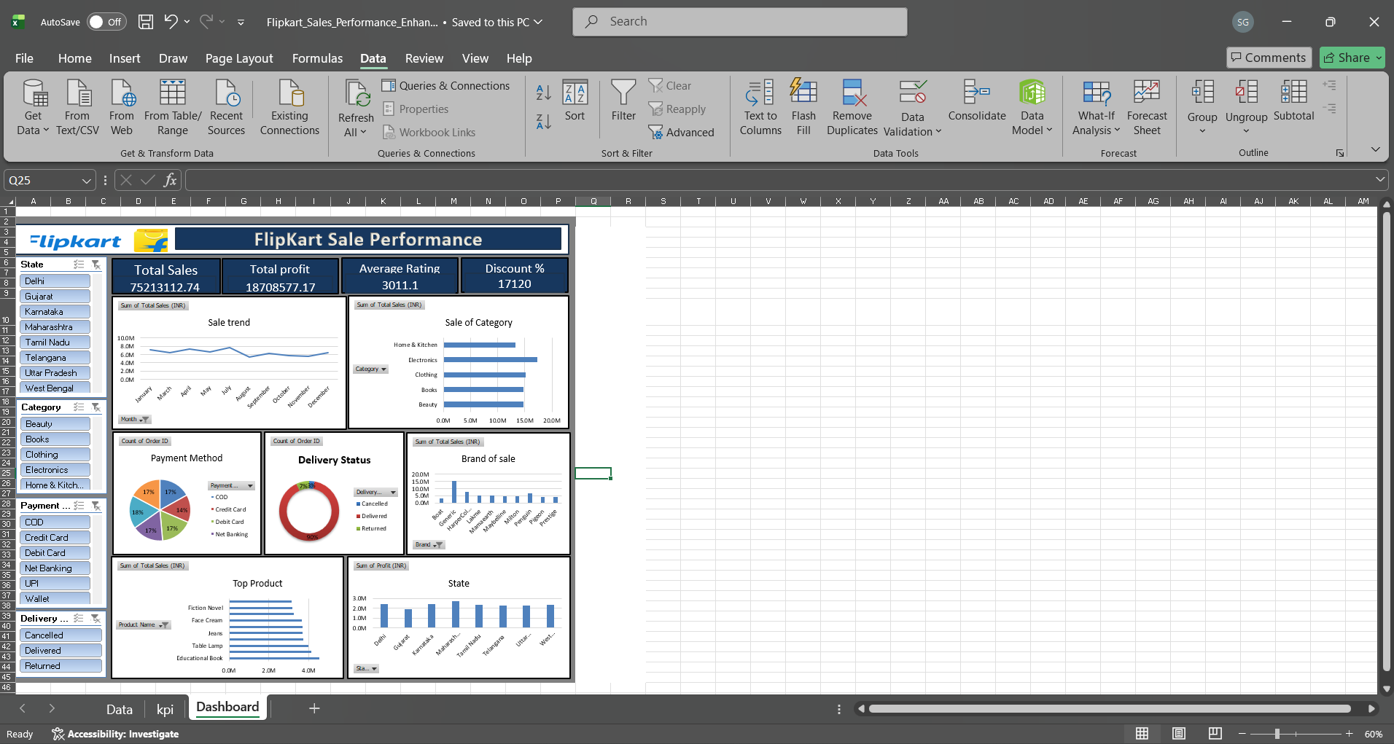

13. Conclusion
The Flipkart Sales Performance Dashboard successfully demonstrates how a publicly available dataset from Kaggle can be transformed into meaningful business insights using Microsoft Power BI. Through effective data preparation, modeling, DAX calculations, and interactive visualizations, the dashboard provides valuable information about sales performance, profitability, customer behavior, and regional trends.
The project highlights the practical application of Business Intelligence techniques in solving real-world business problems and supports informed decision-making through data-driven analysis.
14. Future Scope
The dashboard can be enhanced further by incorporating additional Business Intelligence features, including:
- Integration with live e-commerce sales data instead of a static Kaggle dataset.
- Real-time dashboard refresh using Power BI Service.
- Sales forecasting using Machine Learning models.
- Customer segmentation through advanced analytics.
- Inventory and supply chain analysis.
- AI-powered anomaly detection and trend prediction.
- Mobile-optimized dashboard reports for business users

